Aluminum High Performance Door Rapid Roll® 3000 ISO  ) |  | 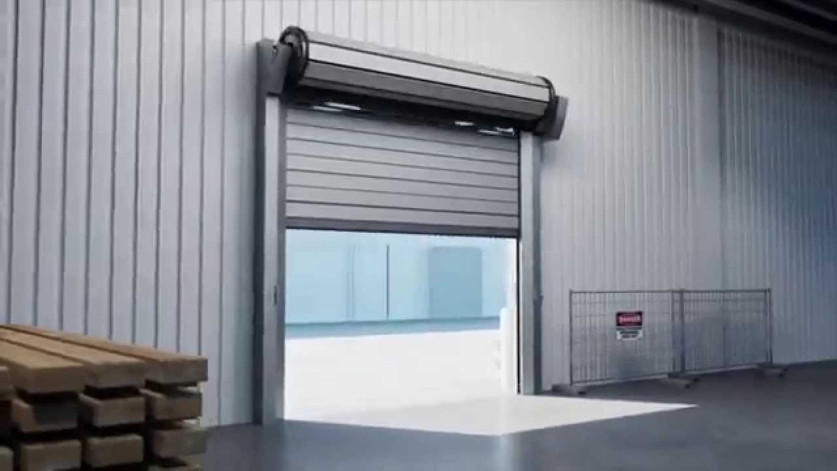
Door type | RR3000 ISO | PL. indicate your requirement
Description | High-performance door, opening in vertical direction, for interior and exterior use
Side frames | are made out of galvanized steel profiles. A patented channeled area avoids critical wear of the lamella ends and smoothens the door run
Door curtain | consists of highly thermally insulated sandwich lamellas consisting of foam (thickness 50 mm) covered by metal sheet trays in silver (RAL 9006). A doubled sealing system links the lamellas ensuring excellent wind and water tightness and a smooth run of the door. Optionally window lamellas can be integrated in the door blade. The clear window entail the entire door width with a transparency of 65 %. Thanks for their individual suspension from the rubber belt, each slat can be replaced individually, rapidly and easily.
Wind protection | class 2-3 (EN 12424)
Drive unit | gear motor 1,1 KW. Chain drive to reduce mounting space to the side
Protection | IP 55
Control system | Albany MCC, with vector control technology and boost function at start-up. Graphic display and foil keypad for easy guided operation. Easy access to all important information for operation and service
Control voltage | 24 V DC
Supply voltage | 3L/(N)PE 380/400/415/440V; 50/60 Hz  Transformator necessary for 220/230/500V; 50/60 Hz.
Safety devices | Door line photo-cell,  drop down protection by integrated balancing system
Manual activation | By releasing the brake at ground level. Partly opening by means of the pre-stressed tension springs
Opening / closing speed | up to max. 2.1/0.7 m/s
Size max | (DW x DH): 7000 x 6000 mm
Make | Albany RR3000 ISO
Options:
Covers | - Top roll cover made of anodized aluminum  - Motor cover made of anodized aluminum
Surface/material | - Standard lamellas: painting in RAL colours (one or both sides)  - Side frames: powder coated in RAL colours  - Top roll cover and motor cover: powder coated in RAL colours
Miscellaneous | Actuators  Additional safety devices

